Rajshahi University of Engineering & Technology (RUET)



Software development project II

CSE 600

Submitted to: Submitted by:

Professor Dr. Shahid Uz Zaman Ruhul Amin
Professor, Dept. of CSE Roll no:113056
Class:3rdyear 6th semester
Course no: CSE 600
Title of the Project:
Childhood Diseases Expert System(Expert-Medico)

Project Category :
Application of Artificial Intelligence (AI)

Platform used:

Front End : Turbo Prolog
Back End : Database & C

Project Concept:

Human experts are able to solve problems at a high level because they exploit knowledge about their area of expertise. This fact provided the background for the design of programs with expert-based problem solving capabilities. An expert system, which such a program is often called , uses specific knowledge about an area in order to obtain competence comparable to that of a human expert. The specific knowledge may be obtained by interviewing one or more experts in the area in question.

The area “expert systems” is probably the sub-area of artificial intelligence that has achieved the greatest commercial success. Today expert systems are used in a large number of subject areas, ranging from medicine, chemistry and geology to law, politics, and economics. Any area in which decisions are to be made is a potential application are for expert system.

Establishing communication links:

Users

User Interface

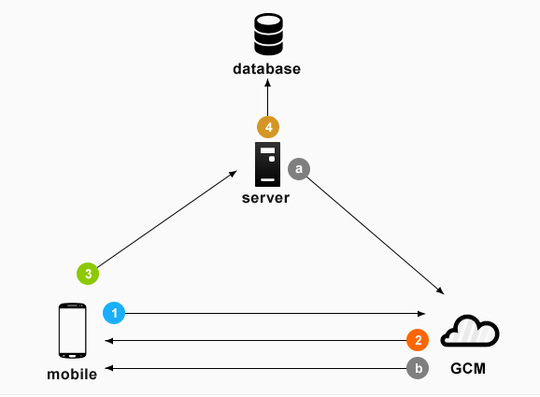
Explanation
component

Inference Machine
Knowledge Base Editor

Knowledge Base

- The Knowledge base is the central component of an expert system. It stores knowledge in the form of facts and rules. Usually predicate logic is used for this purpose.
- The inference machine is used to make logical inference from stored knowledge.
- The user interface is used to exchage information with the user of the system, for example, for input of questions and output of answers.
- The explanation component provides the user with information about the reasoning of the system,including a report of how answers were found by the system .
- The knowledge base editor is used for building and maintaining a knowledge base.

Expert-Medico Snapshot :

# Sequencial interfacing window is captured step by step

Starting Interface:
This window informs about expert-medico capabilty(chilhood disease) .
Then ask for agreement typing ‘A’.

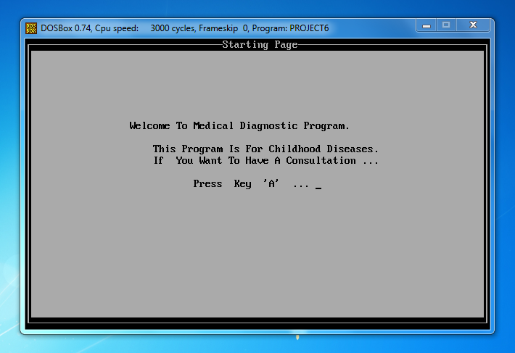

Personal Information:
This is to collect personal information for future reference and for report .

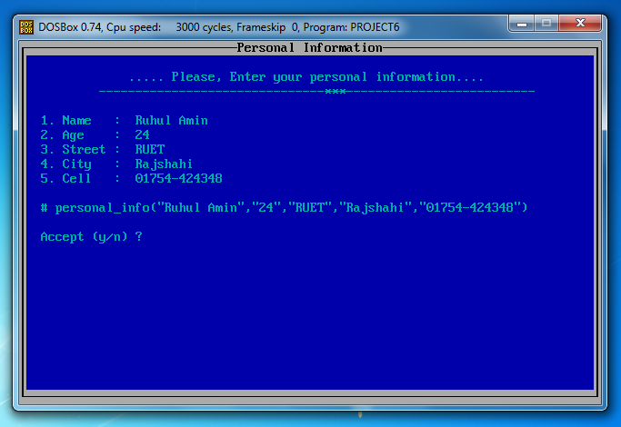
Indication Window:
This ask to interface either by Natural Language(NL) or y/n for short .

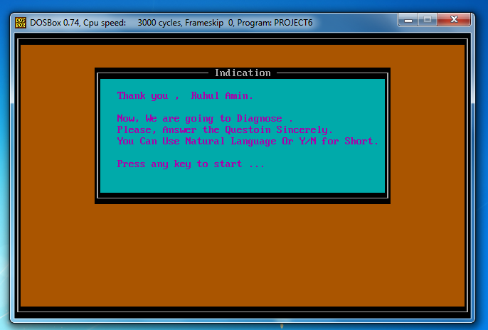

Consultation Interface :
This activity shows a cosultation session with NLP and y/n too.

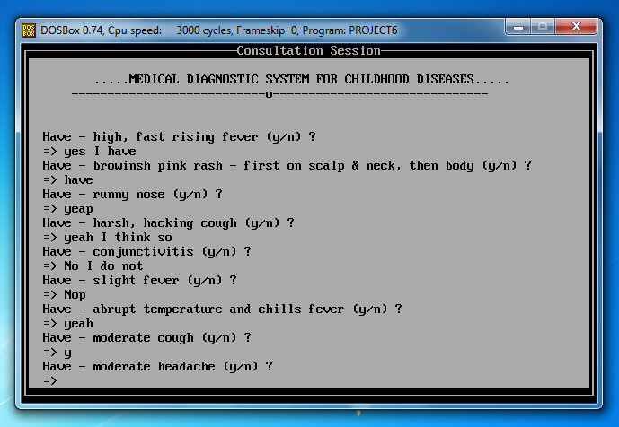
Diagnosed Result Window:
Diagnosed result is shown in a separate window .

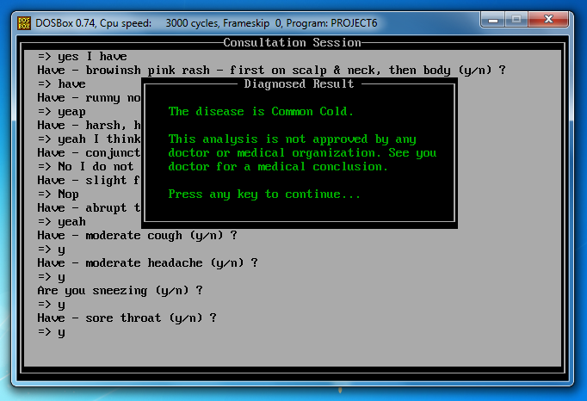

Action Window:
This is for four actions after cosultation session .

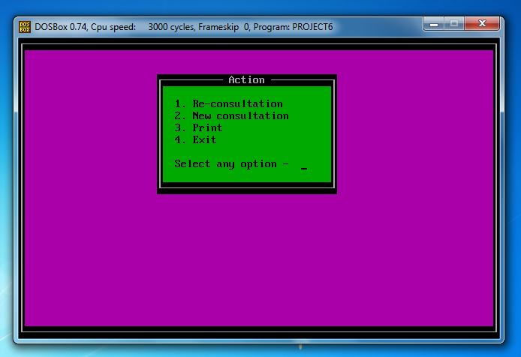
Fail Window:
If expert-medico fail to diagnose any disease, it show this window as failing result.

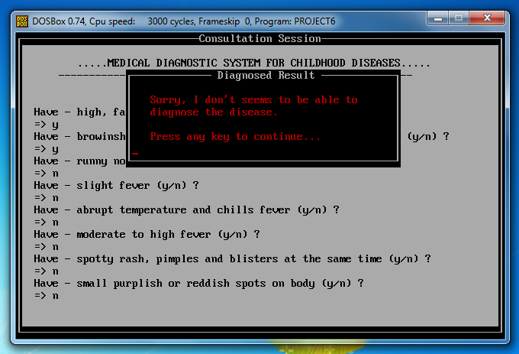

Probabilty Window:
If expert-medico fail to match all symptom but maximum, then it show this result window as probability.

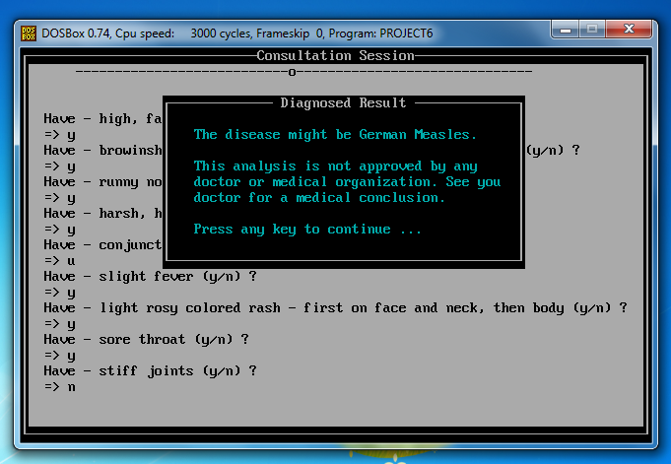
Print Window:
If patient wants, can have a print copy of diagnosed result choosing action button 3 .

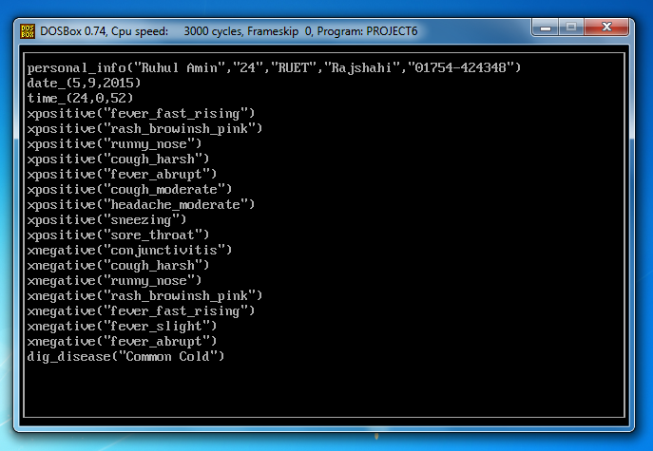

Ending Interface:
Ending Interface shows First Aid logo and thanks as exiting phase.

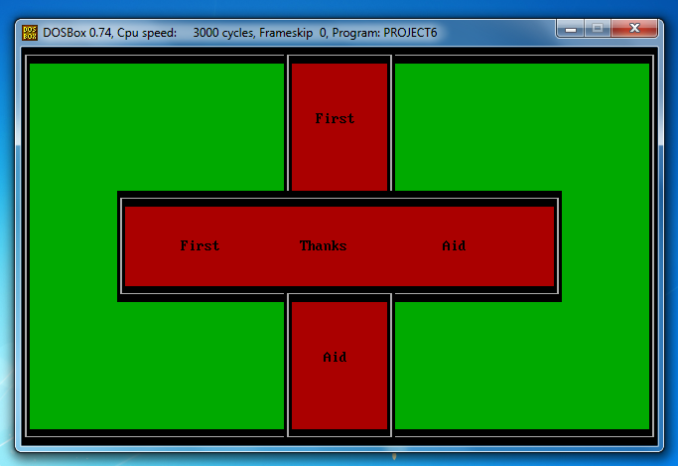

Features of the application :
- Application size is quite small.
- Interactive and user friendly.
- Free interactive consultation.

Conclusion:

The project was completed and tested within the deadline of the project successfully. This project holds the basic mechanism of building a childhood medical diagnosis expert system. The program can be applied for mobile Apps to have instant help. More additional features can be applied to it to make it more useful and interactive.

